**Exploring a vision for the future – St Andrew’s Building needs**

There are many different aspects of developing a church to enable its mission and ministry to the local community to flourish in years to come. One important component to this is the provision of suitable buildings. We have every reason to be grateful to God’s people in the past who have given very generously to enable our main church building to be constructed and maintained to a high standard. Before that, committed giving enabled the building of a temporary church in the 1930’s– which has also served very effectively for many years as a church hall.

However this building has for some years had a rather ramshackle appearance; and it is clear that there are a significant number of other issues that would need to be addressed if it is not to deteriorate further, both structurally and cosmetically. A committee was set up in 2014 to consider how best to proceed, which eventually produced a report discussing half a dozen different options for the future. This led in Jan 2017 to the PCC deciding to commit funds to investigate the feasibility of replacing the current hall with a brand new hall connected to the main church building, selling the old hall site to part-fund the project. The committee commissioned Graeme Renton of Building Design Partnership, who has confirmed the feasibility of a south-side extension, and has produced an attractive design.

He has also engaged a quantity surveyor to provide an accurate assessment of the cost. At £500,000, this is somewhat larger than envisaged in the committee’s 2016 report. However, though our expectations of what we might hope to yield from the sale of the old hall site are slightly reduced, this should still cover nearly a third of the costs. The resulting funding gap £350,000 still represents a significant challenge, although this could possibly be mitigated by having unearthed a potentially significant external source of funding. However, even if this grant is not forthcoming, the building development committee is hoping that the PCC proceed with this proposal.

**Design**

The PCC had previously decided that, were the hall to be replaced, its main priority would be to provide a similar-sized main space. In the first instance this would be to enable the hall’s current usage by church activities to continue, i.e. after-service refreshments, messy church, meals & other special activities, monthly afternoon tea, and children’s holiday club). Secondly it would provide a far more attractive space in which to consider developing new approaches to mission (maybe including Café church). Thirdly it would offer better quality space for community groups - which currently include Beavers, Cubs, Ranger Guides, Martial Arts, no less than 4 Bowling clubs, Slimming World, and regular one-off bookings such as children’s parties.

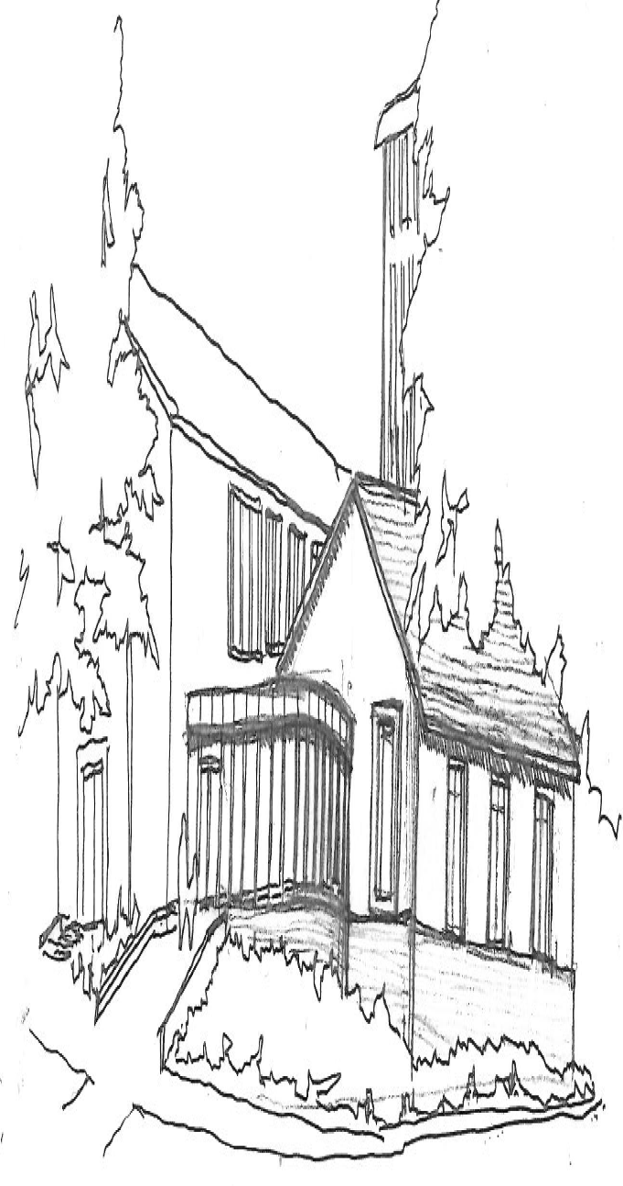The committee interviewed 4 architects before appointing Graeme Renton. He brings significant experience of working on church extensions, and had submitted two initial sketch schemes which we liked. Once engaged he commissioned a complete site survey, and presented several different designs. These were all on the south side of the church as he does not envisage problems in obtaining planning permission for this, and it leaves all of the existing hall site available to sell. The design that we are recommending to the PCC is pictured.

Materials envisaged:

- Tiled roof   
 - Rendered walls  
 - Glazed foyer

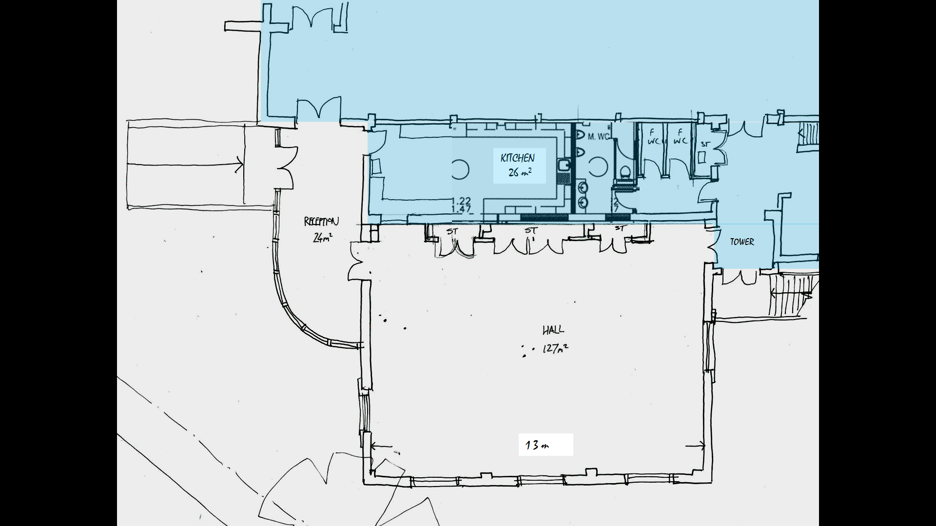**Notes**

*Existing building shaded*

TOWER

*Existing church building, shaded yellow*

1. Excluding utilities, the floor space of our present hall comprises 130 sqm (main space), 34 sqm(stage) + 4sqm (lobby). The committee noted the PCC’s aspiration to broadly replicate this area in the new building; although we have felt that there will be many advantages in providing a greater proportion of the total space in an entrance foyer. The plan therefore gives a main hall space of 127 sqm and foyer of 24sqm.

*Existing building shaded*

1. Our architect’s view is that there is enough space on the site for a bigger building; and indeed an initial scheme was developed in some detail providing a main hall space of 133sqm with a sliding partition into a 68sq entrance/reception area. However the committee felt that the cost of this scheme was significantly higher than we would be able to recommend to the PCC, as it was over £100,000 more than the proposal we are presenting. If the PCC were interested in exploring this option though, the work for it has already been done.
2. In order to prevent costs from further escalating, the design depicted also limits the space for kitchen and toilets to the present south transept. The plan above is just one of many options for this area – in this case still giving the same provision of toilets as our current hall (in addition to the 2 wheelchair accessible toilets that we already have); and allowing for a 26 sqm kitchen. As well as deciding on the balance between kitchen and toilet provision, the PCC would also need to choose the best location for doors and serving hatch(es), and could even opt to swap the siting of the kitchen and toilets.
3. The committee envisage relocating the memorial book and remembrance wreath, and possibly some of the associated furnishings, to either the front or the back of the Lady Chapel.
4. The scheme presented does not necessitate the removal of the tower; although this is still possible. The PCC have previously indicated their strong preference for removal, partly because otherwise it requires major repair. It would of course be far easier to remove before an extension had been built, but this would require faculty permission from the diocese.
5. This scheme envisages that the new entrance would come to be used as the main entrance both to the hall and the church. The existing church main entrance would remain unaltered at this stage, partly to limit costs and partly to provide a straight path through the building for funeral processions, and if desired weddings too.
6. The committee considered schemes which provided an office at the front of the building, but decided that in their view this would have a number of disadvantages. If in future office space were needed on St Andrew’s site, we consider that the clergy vestry or choir vestry are better placed to fulfil this role (with suitable adaption of fittings to enable this to combine with their present use).

**Sale of land**

The committee discussed at length several different options including i) selling the existing car park, and converting the old hall site as a car park, and ii) reconfiguring the parking provision to enable us to sell off portions both of the old hall site, and of the existing car park with frontages on Pilkington Ave and The Plaisaunce respectively.   
Our discussions with our architect and 3 surveyors we approached have however led us to the conclusion that the best option would be simply to sell the old hall site, most probably after having obtained planning for 2 detached houses at the front of the site.

All of our land currently has a covenant preventing its use for residential development. A previous report indicated the committee’s confidence that this would be readily waived to enable us to benefit from the full proceeds of the land sale. This is now looking unlikely, and the solicitor for the diocesan trust has advised that in order to get the covenant relaxed, we should reckon on having to pay the borough council 33% of the ‘uplift’ from the site’s notional present value.

The surveyor’s estimate of the current market valuation for a clear site with the above planning permission in place is £250K. This would need to be reduced to £235K to allow for the costs of demolishing the hall, and perhaps to £210K to allow for a surveyor/estate agent’s probable over-optimism. We would also need to allow for further deductions of: £5K to cover the costs of applying for planning permission and selling; and 33% of the uplift from the site’s present approx £50K valuation would represent a further expenditure of £52K. This should however still leave us a little over £150K to apply towards the new building

**Improving access between church and parish room**

Due to the costs already cited, we consider it more likely that the PCC will want to delay addressing this issue to a later date, although of course the decision could be taken to combine the projects

Discussion with our architect has led to 2 alternative approaches

*Scheme a (without a lift between floors, cost roughly estimated at £30-40,000)*

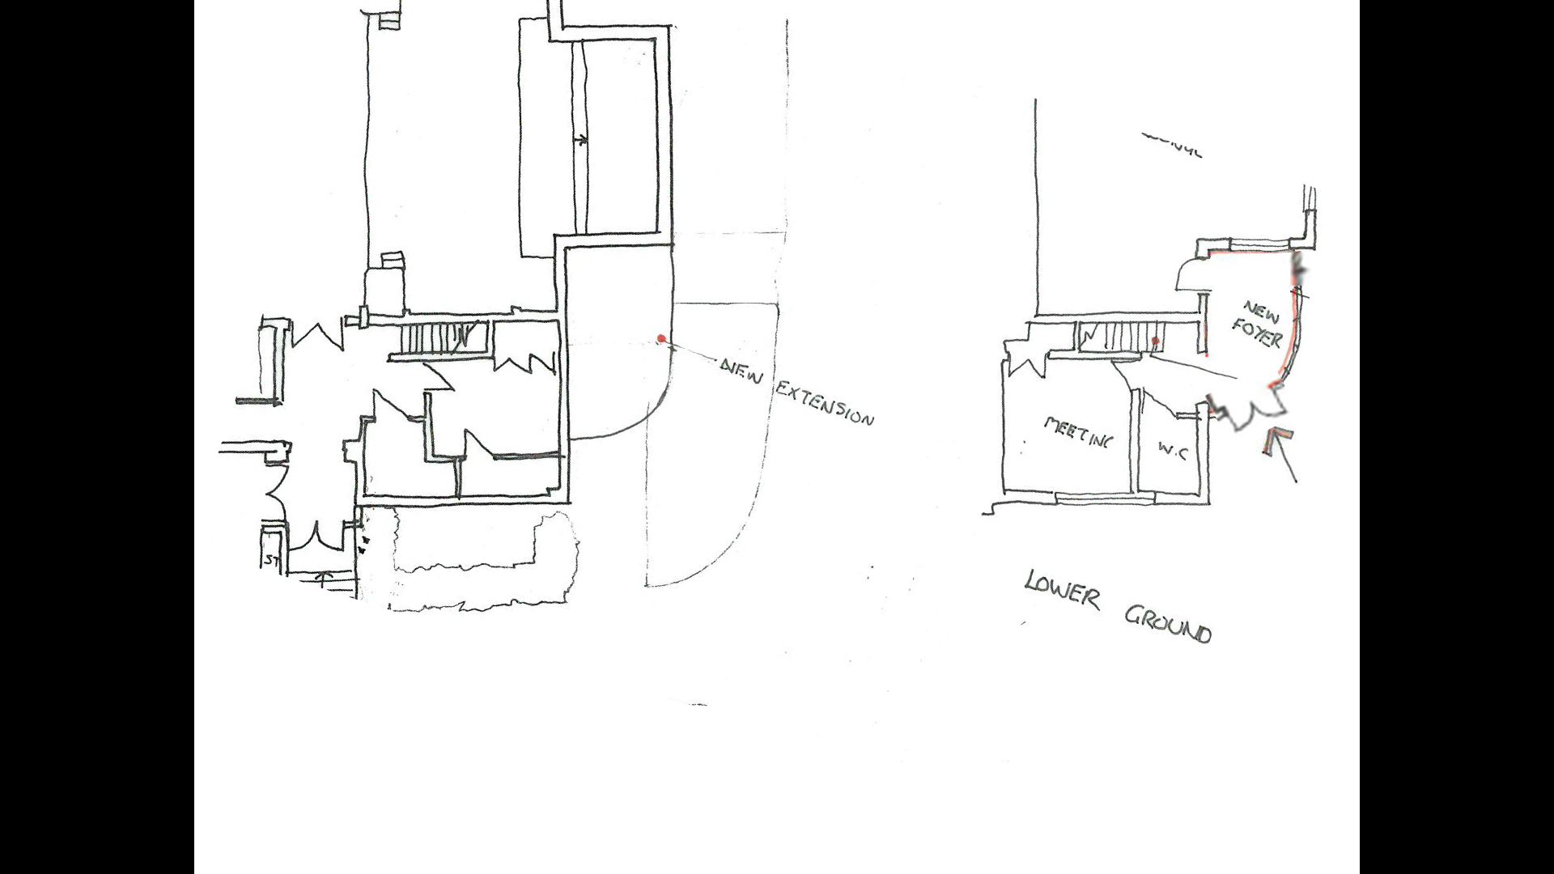Adjusting present staircase to reduce stair pitch and add in-line landing. As this would obstruct the present door to the parish room, this necessitates the construction of a small new external foyer; although this could be designed to provide a brighter access into the building at this lower level.

*Upper Level Lower Level*

*Scheme b (including a lift between floors)*

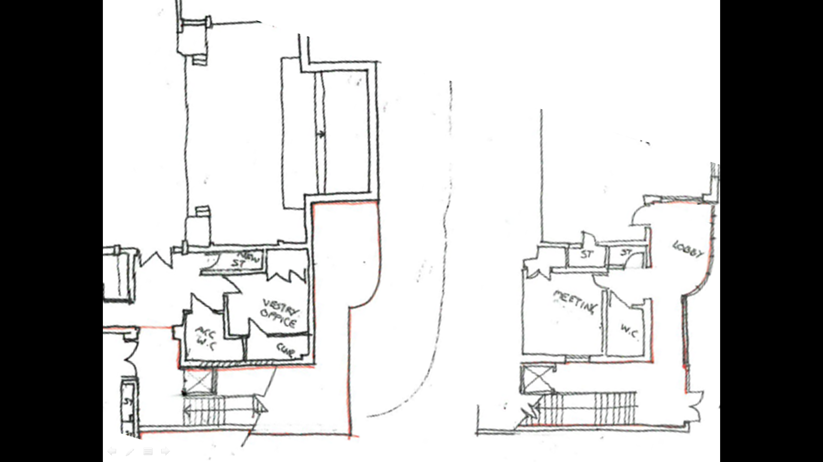In order to provide a simple platform lift to enable wheelchair movement between the 2 levels, more extensive alterations would be required; our architect is clear that the cost of the scheme below would be in excess of £100,000

**Possible External funding**

Though any church building project might expect a small number of grants, the current low interest rates are not producing capital trusts with much income to distribute. Furthermore, most of the support offered is focussed on areas of economic need. However a significant source of funding for church projects providing community facilities over the last 20 years has been from grants that landfill providers are expected to make to community projects in their locality in lieu of taxation. Contact with Red Industries who operate the Walleys landfill in Cemetery Rd, Silverdale led to their asking to visit our site; and once planning permission had been obtained they would be interested in giving our project serious consideration

**Options for the future** Even if improving access between levels is not addressed at this stage, it is clear that the net cost of this scheme (excluding any external funding) is around £350,000. The committee are nonetheless unanimous in encouraging the PCC to pursue this.

The other option recommended in our summer 2016 report, a £210,000 refurbishment of our existing hall to provide perhaps another 40 years of life, remains a feasible path. However even this level of spending will leave a building which both visually and materially shows signs of its years. (Both the 2016 report and the paper detailing the refurbishment options are available at the back of church or on www.churchinthewestlands.org.uk/buildings/ )

As an alternative, Newcastle Baptist Church have recently replaced their ageing hall with a modular building, and the company they used, Springfield, has visited our site. They indicated costs of around £220K for a similar flat-roof building, or around £280K for one with a shallow pitch roof and brick lookalike walls. There would not however be room for this kind of separate building on the south side of the church, and so at most only a part of the hall site could be available to be sold to contribute towards this cost. Another option would be for more attractive timber framed building, although this would increase the cost to around £350,000.

The default option of course also remains - broadly staying as we are, perhaps funding some combination of pressing external repairs to the hall, and internal cosmetic improvements as described in section 7 of our previous report. However the committee feel that this merely delays the inevitable; and that despite the costs, the time has come when we should appeal to the congregation to give generously to provide a more attractive, and more long-term, base for our gospel mission to the surrounding community. The PCC are therefore informing the congregation, and will note any views expressed, before deciding whether or not to invest further in applying for planning permission. Once granted, a formal appeal could then be launched.