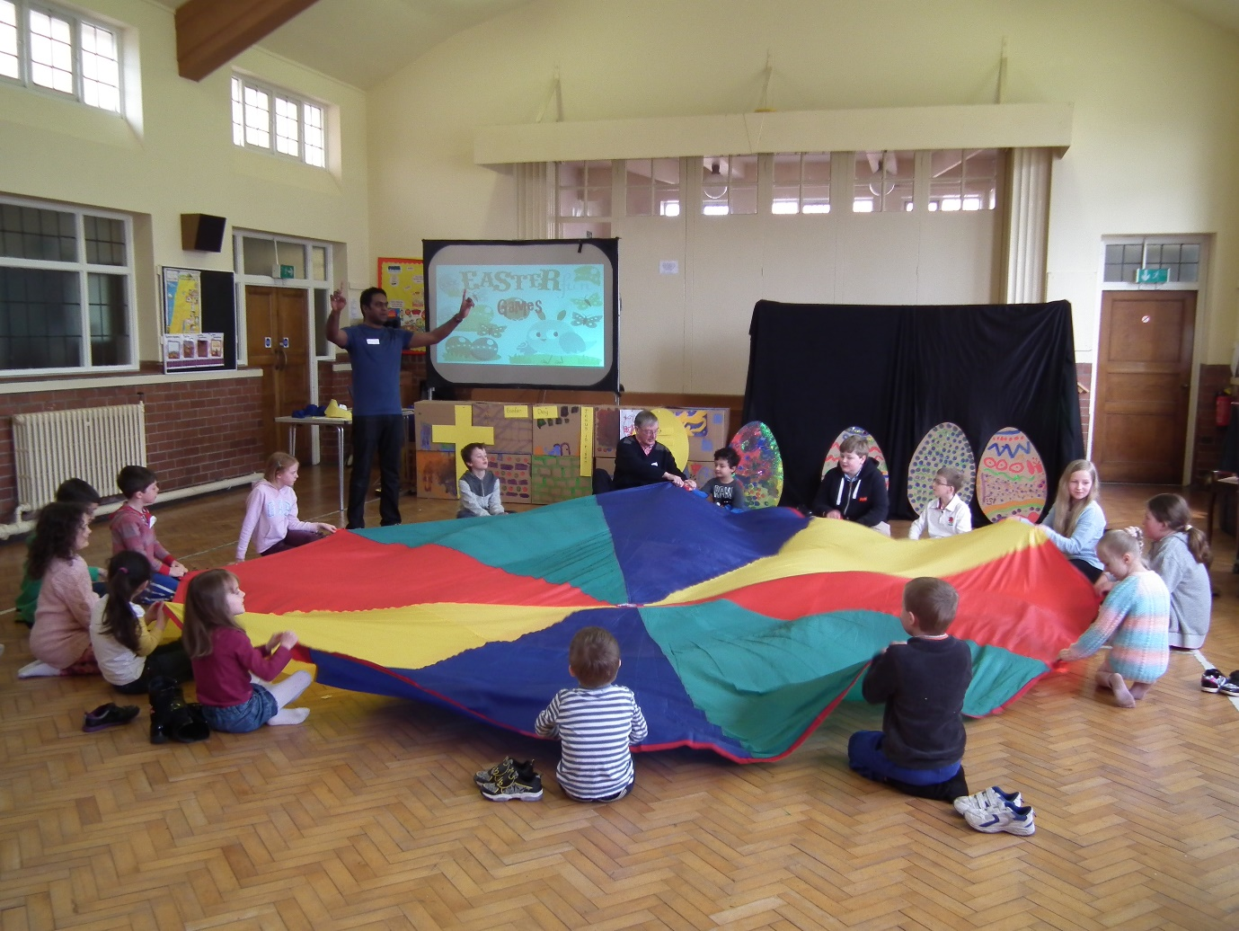
Children and Families Worker
The Church in the Westlands
Newcastle-under-Lyme

Welcome
This is an exciting time within our churches as we consider the next stage in our ministry and outreach to Children and Families.
There is excellent work going on, with many committed and gifted volunteer leaders and helpers. The challenge we face is to find ways of passing on our faith in a setting where, at the moment, families seem far less easily inclined to try out the church on a Sunday morning than was the case 15 years ago (let alone 50)
The job description is a new one – although several aspects of it are carried over from the Youth & Children’s Worker post that ran from 2005-2017. Other parts of the job will be taking over responsibilities from our curate who is preparing to move on; others are new.
We are looking for...
- Someone with an enthusiasm to lead, enable and develop our children’s and families’ ministries, offering biblical teaching and social activities to help build a life-long faith in Christ and to encourage personal growth.
- Ideally we would like to appoint a candidate with significant maturity and experience in this area of ministry, to take a significant responsibility for co-ordination and strategy. We are however also open to candidates at a much earlier stage in their professional development, and a job description will be tailored to fit the individual appointed.
- We expect the candidate’s strengths and passions to impact significantly on how the role is carried out, utilising their unique gifts, talents and skills eg music, drama, art or crafts, sport etc. We are also open the agreed job description allowing those with experience in other areas to use these skills as well (e.g. preaching, speaking at all age services, adult pastoral ministry, women’s pastoral ministry)
Details
Church-based programme
- Sunday Club. We regard this as a vital ministry, and are continuing for the most part with the provision of separate groups for 3-7’s, 7-11’s and 11-14’s, though occasionally combining the 2 primary age groups. Our worker is most likely to be regularly involved with our 3-7’s who are currently dependent on a single main adult leader.

- Little Sparklers. After a couple of years of meeting once a month, our curate’s arrival enabled this to develop into a weekly ministry. As well as time for toddler play, refreshments, chat and everyday fun songs, there is also a significant time given to Christian songs and teaching/ bible story time. There is a very able co-leader, whose work commitments may or may not enable them to share the lead with our newly appointed worker when our curate leaves, although there is already one other person on board to help with refreshments etc.
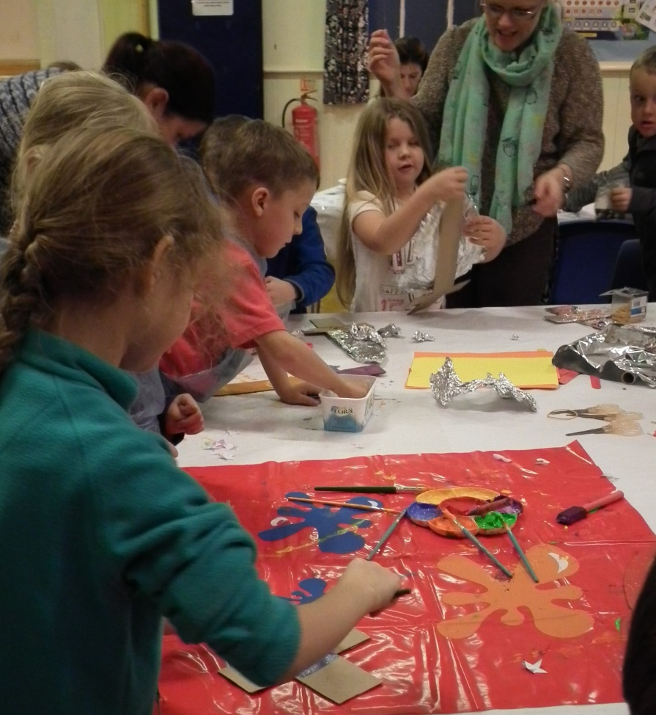
- Messy Church. Our curate currently leads a very gifted team, who have a strong Christian commitment too. Since starting 8 years ago each Messy Church session has consistently attracted 15-30 0-8’s and around the same number of parents. For over half of these, this is their only significant regular contact with church life.
In order to increase the potential for genuine spiritual growth both in the children attending, and maybe even their parents, we envisage continuing to experiment with aspects of each session’s programme. We will also continue to encourage any with a desire to go deeper to try other aspects of our ministry, perhaps again offering a bespoke parent’s enquirers course.
We envisage the post holder either taking over as the overall leader, or being part of leadership team of 2 or 3 heading up this ministry. We have generally had 6 or 7 messy church sessions a year; and a new worker may want to consider the feasibility of moving to monthly meetings to increase the likelihood of more substantial relationships and a stronger sense of community being able to develop.
- Co-ordinating an Annual Summer Holiday Bible Club
- Working with the Vicar, Minister and worship committee to develop ways in which children can participate in different ways in Sunday services in both churches, including especially all age worship.
Schools’ Work
- Sharing with the vicar, (curate) and currently one volunteer in providing weekly KS2 assemblies at Langdale primary and Westlands primary schools; and a weekly KS1 assembly at Langdale primary
- Langdale Primary after-school clubs. Leading and re-launching our KS2 Rock Solid after-school club (which currently has 4 children and one main leader); and supporting the 3 leaders serving the 10 members of our KS1 Stepping Stones club.
Also
- New avenues for Outreach and Evangelism
Obvious possibilities for this include: re-starting a midweek after-school club for KS2 on church premises; developing a lunch-time, after-school, or assemblies ministry in another local primary school; inviting primary classes to an activity/reflection day at the church; recruiting volunteers to present ‘Open the Book’ in schools; Godly Play.
- Ministry to parents
It will be important to take and make opportunities to engage with parents, partly through Informal conversations, with some home visiting, and maybe by arranging occasional special events, or facilitating a parenting course.
- Recruiting and supporting volunteer leaders
Though well supplied with leaders, in several areas of ministry we are dependent on one or two who, though very gifted, may not be able to play an active part for many more years. It will be important to encourage other existing leaders to grow in confidence, and to recruit and arrange training and support for new leaders too.

Management of work
The post is overseen by a committee of representatives from both churches who currently meet 3 times a year. Initially the plan will be to meet with the vicar for a weekly line management meeting to discuss your ministry. We will also negotiate a pattern for prayer, bible study and reflection together each week (or more or often if desired). You will participate in an annual process for appraisal, review and setting objectives; and will also need to produce a termly prayer & information leaflet for church members.

Person specification
Essential
- Is a practicing Christian who is committed to a biblical faith, has a regular prayer life, and is in good standing with the local church and wider community
- Has a passion to share the Christian faith with children and their families and is proficient at publicly speaking to children about the good news of Jesus.
- Is proficient in forming ongoing professional relationships with children, and also able to relate well to the adults they will encounter e.g. as parents/carers, or those who support the post by their prayer/giving.
- Is capable of working alongside our existing children’s work teams, arranging appropriate training, and recruiting & developing new leaders and helpers.
- Is willing to work unsociable hours (a regular working week will include ministry in evenings and Sundays; and we also envisage trips out being included in the programme)
- Is extremely reliable
- Is self-motivated and can work independently, from an office in St Peter’s church complex
- Is capable of independent transport in the South Newcastle locality
- Good standard of written English (email, writing letters etc.) and spoken English (public-speaking, presentations)
- Basic ICT Capabilities i.e. a proficiency at using email, the internet and producing documents.
- Is willing to live within 15 minutes travelling time to the Westlands (or to relocate within a few months of starting the post)
- Flexibility and willingness to learn, to try out new ideas and types of ministry, and to participate in appropriate continuing ministerial/professional development
The post-holder will be expected to become part of our worshipping community, getting to know members of both churches. We will endeavour to find a working pattern to develop which enables him/her to both give and receive ministry.
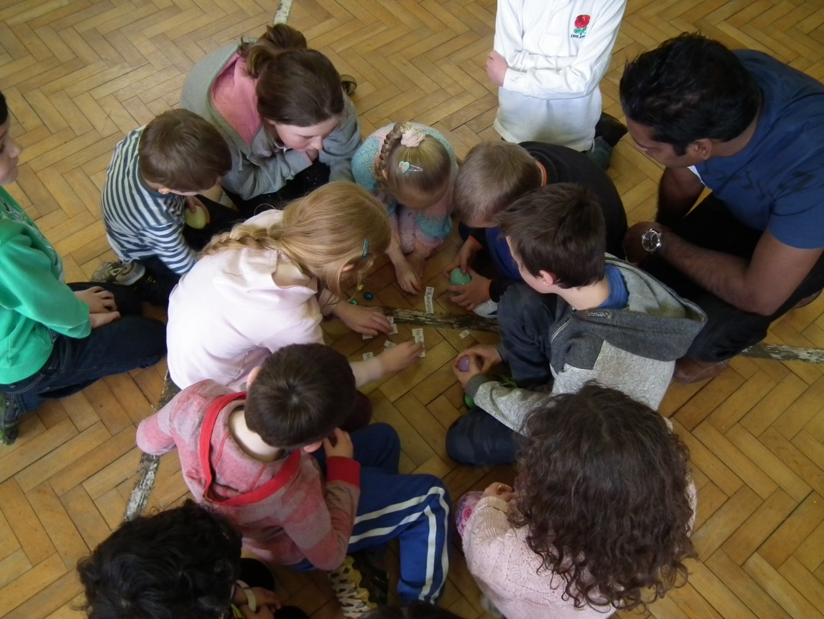
Desirable
- Has at least 3 years experience in youth and community work and/or a relevant qualification (e.g. in church-based childrens ministry, community/childrens/youthwork or a teaching qualification)
- Has experience of working in primary schools
- Has the Experience or Potential of using ICT skills in ministry

Pay
The post is full time, 37.5 hours per week, with four weeks paid leave annually in addition to bank holidays. It would also be open to a part time appointee who was able to offer 20 or more hours per week (salary being adjusted pro rata). We would also be open to a pro-rata contract that allowed some of (or even the majority of) the school holidays to be taken as unpaid leave. A married couple wanting to job share would be favourably considered too.
Salary: to £24,000.
We’d envisage paying a full time appointee just about to graduate with a degree/diploma in children’s ministry £23,000, with a similar figure envisaged for those who instead bring extensive experience in the field. A children’s ministry graduate or qualified teacher with 3 or more years subsequent experience would be offered the full £24,000
We are also open to considering candidates without qualifications and with less extensive relevant experience. A holder of our previous post studied for the Cliff College diploma in youth/children’s ministry while working for us - completing it to degree level with a subsequent employer. If it was decided that a similar kind of route were appropriate for our new appointee, we’d envisage offering £15,000 plus £3,000 course fees – which would enable you to get a vocational diploma or degree without incurring further debt.
The post-holder will be auto enrolled into a pension scheme which is funded by 4% by the post holder and 4% by the church, although it is possible to opt out of this.
Recruitment is subject to an enhanced DBS check, with barred list check.
This is a 3 year position with opportunity for renewal.
The position is currently vacant, but if needed we would be willing to delay the start date by several months for the right person too (perhaps to enable them to finish their training or to complete their existing contract.)

Further Questions and Application Process
We’d very much welcome an informal conversation on the phone with anyone who thinks that they might be interested in the post, Please contact Andrew Dawswell, vicar of St Andrew’s on
01782 619594 (If you’re struggling to catch him, do email ja.dawswell@googlemail.com leaving your phone number).

A further document of background information, and more information about our churches, is also available on www.churchinthewestlands.org.uk The ‘youth and children’s work’ tab of our website takes you to a video produced 18 months ago by our previous member of staff who had a brief for youth and children’s ministry– as has been mentioned several aspect of this will be taken on by the new worker.
An application form can also be downloaded from The Church in the Westlands website www.churchinthewestlands.org.uk.
Please email to ja.dawswell@googlemail.com (or if this isn’t possible ring Andrew Dawswell on 01782 619594 to discuss an alternative method) The application deadline is Wed 11th April . We are planning to conduct interviews for those shortlisted within 2 or 3 weeks of this.
More details – and a video about our youth and children’s ministry made in 2015 can also be found on our website.

